What Do Affected Families Want?
Running alone in the labyrinth or counting on a wraparound support network?
Daniela Capitanucci – AND-Azzardo e Nuove Dipendenze (Italy), Newcastle, November 11th , 2018.
- The Italian context: characteristics of the gambling offer
The process of legalization of gambling, started in Italy since 2003 (through the industrialization of the sector thanks to the concession regime), created a capillary offer which has indiscriminately reached all citizens in their places of life, both through “physical” gambling (what can be found in bars, tobacconists, slot rooms, betting shops, etc.) and through “digital” gambling (online, app, etc.).
- The explosion of the gambling offer in Italy
The main feature of our large gambling offer is to be spread everywhere at a very low threshold, and therefore to be easy accessible for anybody. We have at least:
- 450.000 Slot machines (80% in coffee bars, pubs, tobacconist …)
- 50.000 V.L.T.s (most in gambling venues) – High stakes
- Scratch cards - ticket value: 1-20 euros
- Lotto (fixed quota drawings) and Superenalotto (variable quota drawings): 3 times per week
- Instant Lotto drawings: 1 every 5 minutes
- «Ambetto»: Lotto variation based on near misses cognitive distortion
- Win for life (many drawings per day)
- Sport, horse and other events betting in corner shops
- Bingo
- Texas hold ‘em live
- 3 Casinos - Venice, Saint Vincent, Sanremo (Campione d’Italia just failed – August 2018)
In addition to the land-based offer, we also have a heavy offer of legalized gambling online (poker cash, poker texas hold ‘em, casino games, bingo, scratch cards….).
No wonder that Italy is 1st in Europe regarding the absolute value of gambling losses, the loss per inhabitant (11% more than the UK, over twice the size of France, Germany and Spain) and gambling losses in proportion to GDP-Gross Domestic Product (1,07 percentage points of GDP). (Source: The Economist, Sept. 2nd 2015, digital editions, re-elaboration by Paolo Jarre 2018).
According to “The Economist” Italy is 4th in the world for Annual Gambling Losses (see table 1).
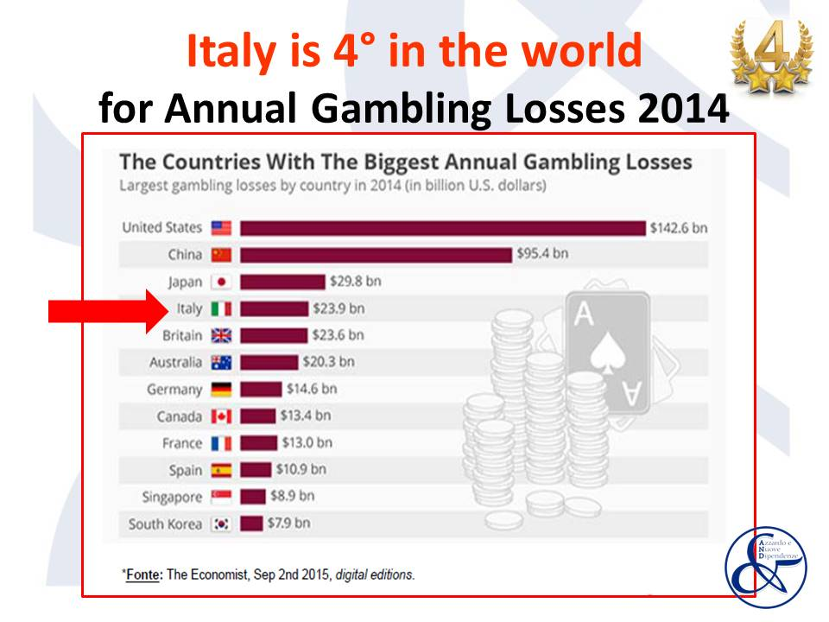
Table 1
The revenue from legalized gambling increased from 2004 to 2017. (See Table 2).
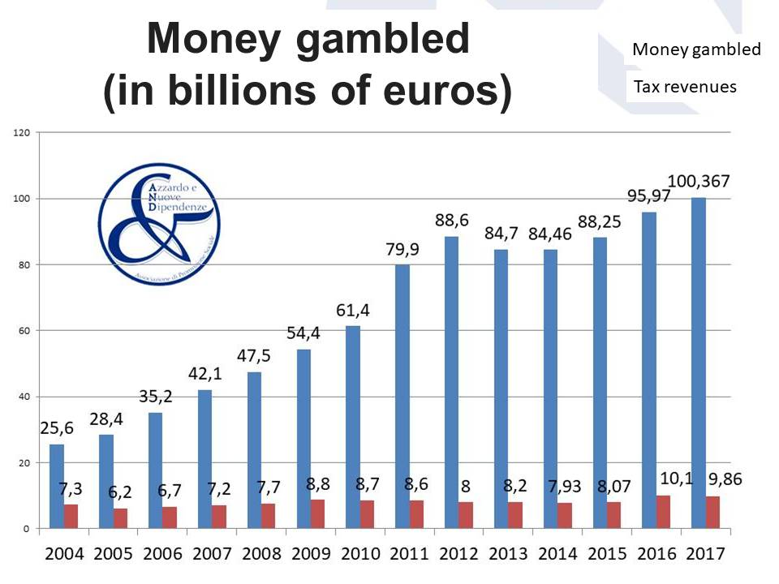
Table 2
- Gambling behaviour in Italy
Regarding gambling behaviour, 54% (23.894.000 people) of the Italian population (total 60.418.711) aged 18-74 (44.248.148 people) gambled at least once in the last 12 months. From 302.093 to 1.329.211 people are estimated to be Pathological Gamblers (0,5% - 2,2% on Total Population; 1,3%-5,6% on gamblers aged 18-74).
Therefore, considering the Disordered Gambling rate at 2,2%, at least one citizen out of 6 «co-exists» - directly or indirectly - with harms caused from gambling disorder: 9 million of this people are relatives (See table 3).
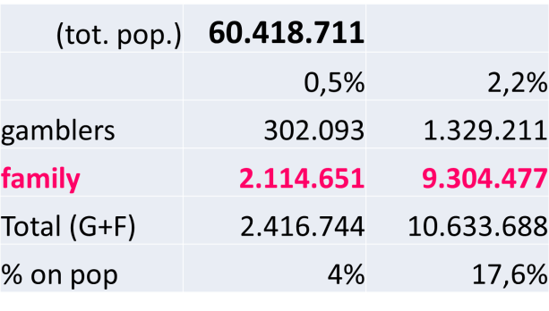
Table 3
- Gambling and the family
Family is the first victim of gambling. The traditional Italian family, often still enlarged, is composed of several people in close relationship with each other, transgenerational (many times consisting of three generational levels). The particular structure of the Italian family makes harm hitting a large variety of family members: of course spouses and partners, but also sons and daughters, parents, and even other relatives (grandparents, nephews, cousins….).
Each family member has to deal with several adverse situations: changes in the gambler’s mood and behaviour, frequent conflicts and quarrels (often in front of children), decreased quality of life and social closure. These side effects of disordered gambling are common also in other addictions, but they always sums with the specific harm of gambling addiction: the reduction of economic stability. The fluctuations in the financial situation that can go from a slightly critical to a tragic one, up to total bankruptcy. It can be less or more severe, but the family is always hit by a decrease in its economic safeness.
The loss of trust is another important issue to consider. Traumas to trust are determined by lies and gambler’s minimizations, relapses and – again - revelations in stages of the real entity of the economic hole. Without trust, there is instability and uncertainty for the present, for the past and for the future. Uncertainty involves a condition of anxiety, fear and chronic stress.
Trauma theory is useful to understand what is going on with them: “t” traumas are very common in the everyday life of gamblers’ family members. Repeated experiences of neglect in caring and / or having been exposed to excessive and constant reprimands, having suffered verbal or physical violence, being bullied, having been burned by the breakup of an important relationship, having been abandoned, having suffered the sudden loss of economic security, etc. are part of their everyday life burden.
They severely affect their sense of personal value, security, self-esteem and perception of effectiveness. Furthermore, when we meet the gamblers’ family, exposure to trauma is often still ongoing. For traumas with a lowercase “t”, usually there are no clear memories of specific episodes. Family members might experience very vague feelings or memories that in their present life can outburst through various general ills. Among these, panic attacks, obsessions, phobias, chronic pains, anxiety, depression, somatization, sense of dissatisfaction, nervousness, internal agitation, easy quarrelsome, constant feeling of never being understood, chronic sensation of loneliness and abandonment, etc. All these might be signs of failure to process disturbing episodes, which continue to take place in the present by creating general uneasiness and/or illness. Specific treatment of traumatic conditions is necessary.

- Temporal declination of harms
Harm and impairment are long lasting. They can be distinguished in general harms (experienced at any level of constant and non-occasional gambling), crisis harms (harms related to the period in which help was requested) and legacy harms (experienced even after cessation of gambling behaviour). The latter are particularly relevant in disordered gambling (both for the gambler and for the family). (See table 4 and 5).
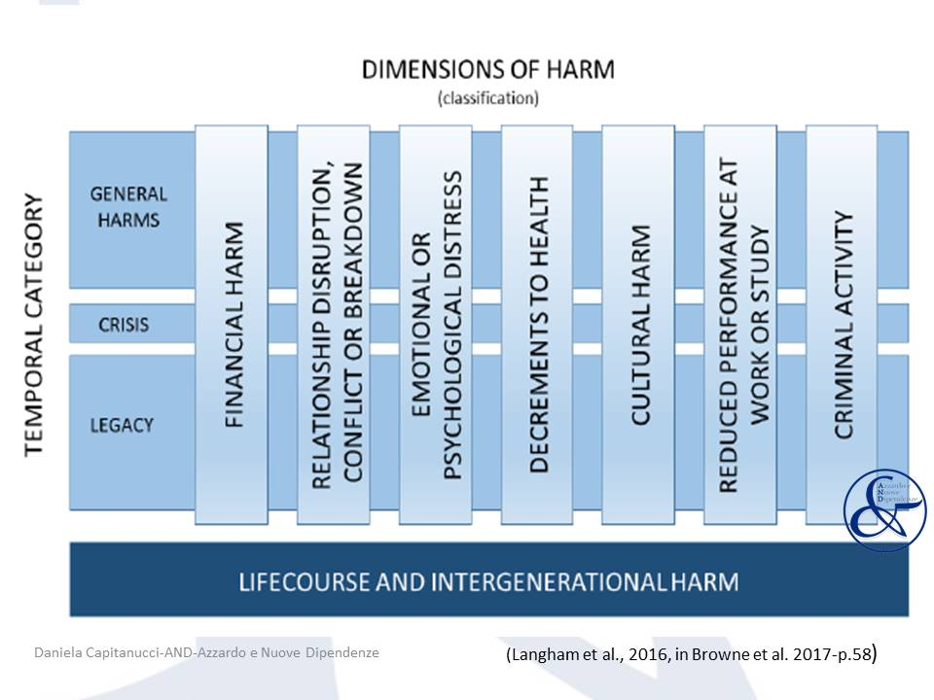
Table 4
Table 5 - Detailed harm taxonomy, in Browne et al. 2016-p.76

- Which model will help «Gambled Families»?
The families of gamblers live a heavy situation that negatively affects many spheres of their lives. This significantly affects the decrease in their quality of life and well-being.
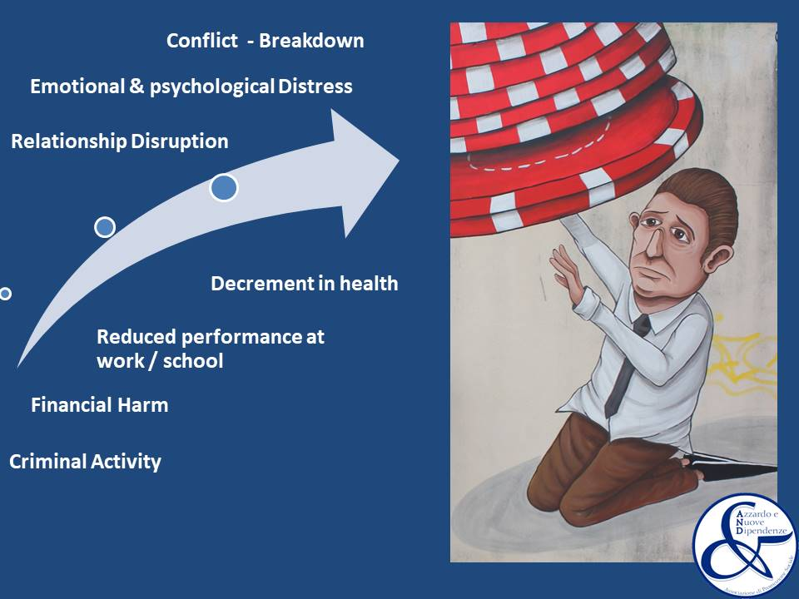
It is therefore necessary to provide a system of services for the taking in charge that takes into account this specificity and responds appropriately. The primary objective is to avoid that even the search for support turns into further effort for the already exhausted family member. What kind of network of services is therefore more appropriate? Their needs might require interventions from the following specialized branches: Family Counselling Services (for individual, couple and family therapy), Psychiatric Services (for comorbidity issues), Addiction Services (for Gambling Treatment), financial advice and debt reconstruction, legal advice (for harm reduction and protection, divorce, etc.), Psychological support to children, and probably many other.
Are these offers better available to the family in a fragmented and decentralized contest? Alternatively, would it be better to foresee that they are organized, integrated and centralized?
Having to seek help in an unfavourable psychological condition (shame for the stigma, post-traumatic psychological functioning, etc.) can aggravate the uncomfortable situation of the family member. Moreover, it can even move away from the support necessary to overcome the critical situation in which they find themselves. Therefore, structuring services around the needs of family members can lighten the weight they carry, bring them closer to the treatment path and - in the long run - increase the effectiveness of the support they can count on. I have in mind not a family member who has to move in the network of services, meeting more professionals in many different structures, but rather a person who enters a service able to offer her/him all the services she/he needs.
- Conclusions
In conclusion, three are the main points to support PG families to get out of the labyrinth in which they found themselves.
- Consider and treat their discomfort as the most appropriate reaction to the repeated traumas they are suffering every day.
- Organize around their needs exhaustive and complete support services, adequate to the weights that they are carrying (offering support in all impacted areas, also practical, within the same centre).
- Promote cultural change in the community: give voice to their suffering.

